关于学生申请英文学历证明和学位证明的管理办法

近期接到学生要求学校出具英文版的学历证明和学位证明的申请，经咨询兄弟院校做法同时结合我院实际，本着服务学生的原则，学院决定：

1、学校制定统一的英文版学历证明和学位证明的模板。
2、学生申请英文版证明，学校提供电子版的模板，由学生自己按模板来打印证明书。
3、学生持学历证书和学位证书原件和英文版证明书到相关部门盖章。

说明：英文学历证明适用于所有毕业生，英文学位证明适用于2008年9月之后入学的毕业生；2008年9月之前入学的学生英文学位证明需到天津商业大学按天津商业大学的相关规定办理。

仅供本科生出国留学参考：

以下模板为本科毕业生的毕业证书和学位证书，大家对应下载后可以修改各自证书中相关的个人信息（红色画线部分）。
要求：一张A4大小的纸，上半页为证书的复印件，下半页为英文翻译。字的大小可以调整一下，落款处校长名字及日期一定要与证书上的校长名字和颁发日期一致。

后附证明模板。

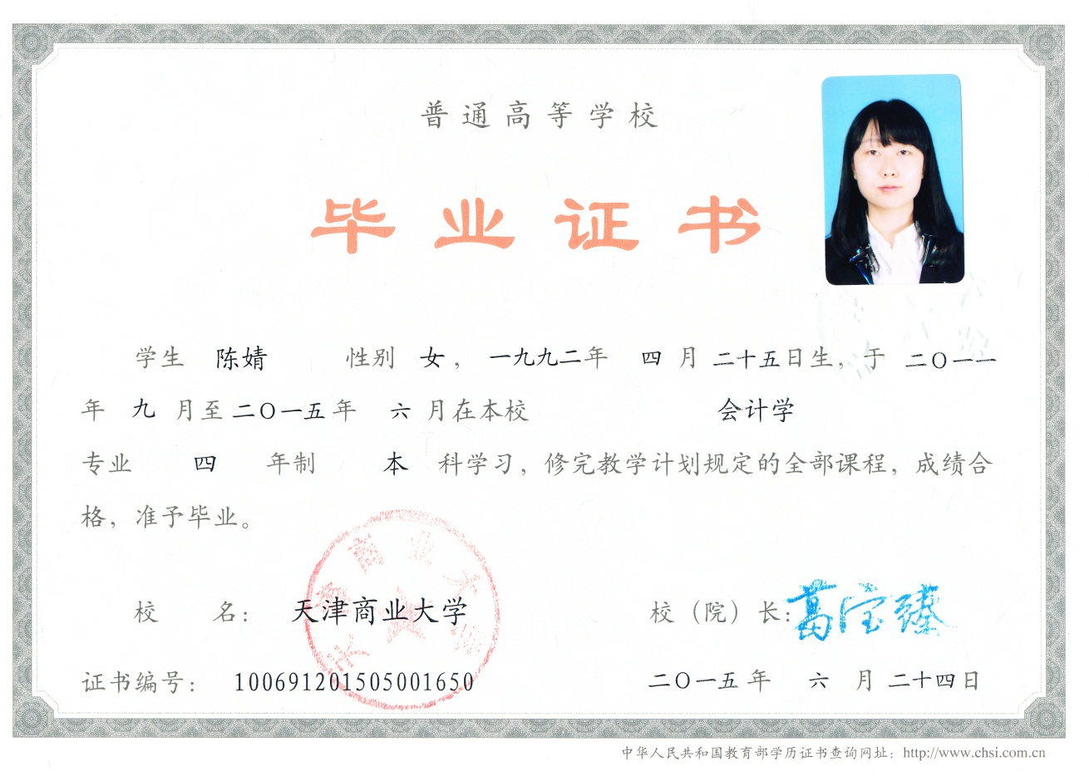

Graduation Certificate

This is to certify that student Chen Jing, female, born on 25th Apr. 1992, studied in the major of Accounting in Tianjin University of Commerce Boustead College, finished four-year undergraduate course prescribed in teaching plan from Sept. 2011 to Jun. 2015, and till now she has passed all the examinations of the courses with sufficient scores. Therefore, she is granted to graduate.

Tianjin University of Commerce Boustead College
President: 注：与毕业证校（院）长一致的签名图片
Date: 24th June 2015

No. 100691201505001650

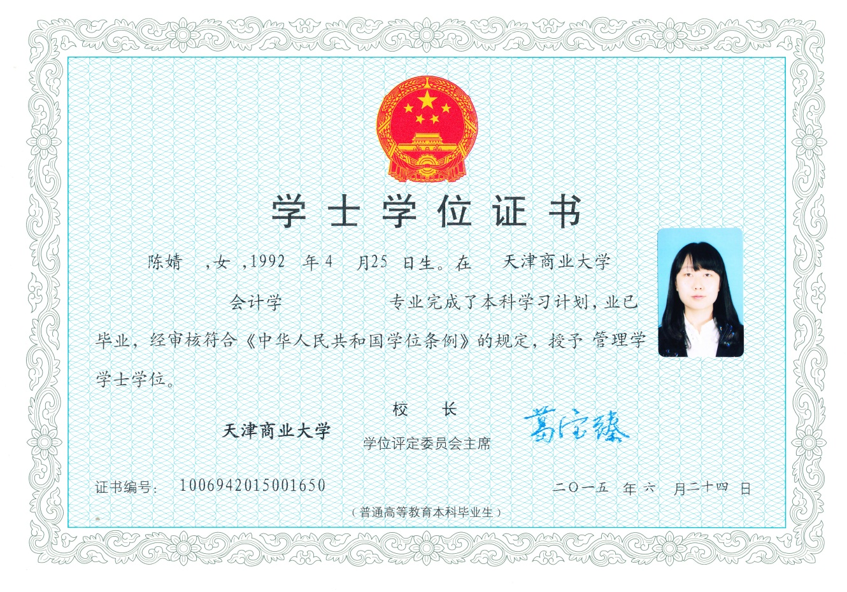

The Degree Awarding Committee, in accordance with “The Regulations Concerning
Academic Degrees in the People’s Republic of China”, has conferred upon
Chen Jing
the degree of
BACHELOR OF MANAGEMENT SCIENCES
mAJOR OF Accounting
with all its rights, privileges and honors
given at Tianjin , China, on the 24th Jun., in the year of 2015
注：应与学位证校（院）长一致的签名图片 | 注：应与学位证校（院）长一致的签名图片
President，  Tianjin University of Commerce Boustead College | Chairman,  Degree Awarding Committee

No.1006942015001650 Entrance of Jinba Road, Bei-chen District, Tianjin, China 30013

